**DRL not interpolated Old Data**

Learning Regression Tree...

Elapsed time is 0.582757 seconds.

Training RMSE(W): 6.95, R2: 0.966, RMSE/peak: 0.0160, NRMSD: 2.49

Learning a cross validated tree...

Elapsed time is 5.038816 seconds.

Cross Validated Training RMSE(W): 14.01, R2: 0.862, RMSE/peak 0.0323, NRMSD: 5.03

Learning a Random Forest...

Elapsed time is 162.567193 seconds.

Random Forests Training RMSE(W): 7.98, R2: 0.955, RMSE/peak 0.0184, NRMSD: 2.86

Testing RMSE(W): 30.02, R2: 0.225, RMSE/peak: 0.0850, NRMSD: 11.36

Cross Validated Testing RMSE(W): 28.84, R2: 0.284, RMSE/peak 0.0816, NRMSD: 10.91

RF (Testing) RMSE(W): 23.89, R2: 0.509, RMSE/peak 0.0676, NRMSD: 9.04

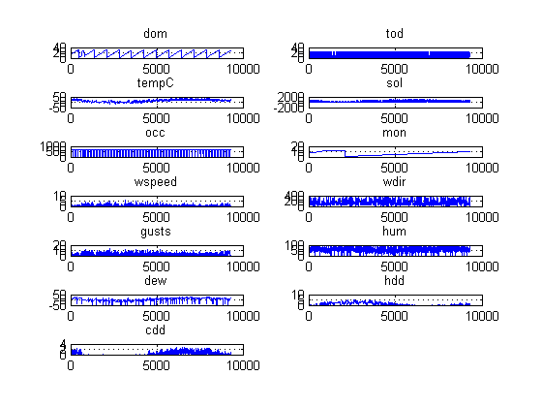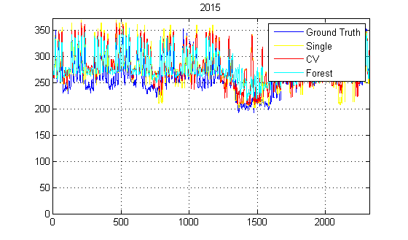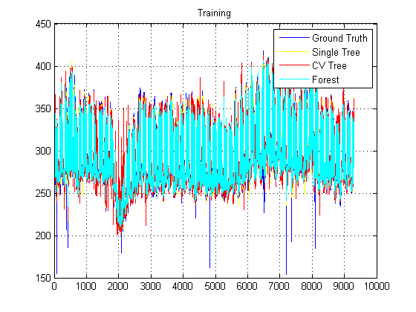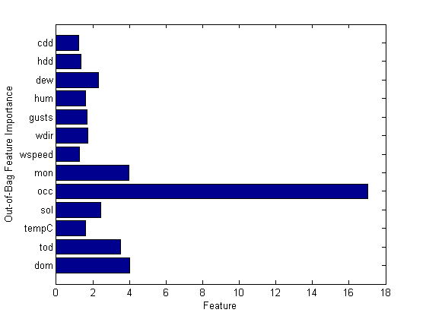

**DRL Interpolated Old Data**

Learning Regression Tree...

Elapsed time is 0.351987 seconds.

Training RMSE(W): 9.81, R2: 0.933, RMSE/peak: 0.0227, NRMSD: 3.52

Learning a cross validated tree...

Elapsed time is 2.938056 seconds.

Cross Validated Training RMSE(W): 14.82, R2: 0.847, RMSE/peak 0.0342, NRMSD: 5.32

Learning a Random Forest...

Elapsed time is 101.382899 seconds.

Random Forests Training RMSE(W): 10.73, R2: 0.920, RMSE/peak 0.0248, NRMSD: 3.85

Testing RMSE(W): 29.80, R2: 0.228, RMSE/peak: 0.0843, NRMSD: 11.25

Cross Validated Testing RMSE(W): 28.06, R2: 0.315, RMSE/peak 0.0794, NRMSD: 10.60

RF (Testing) RMSE(W): 23.89, R2: 0.504, RMSE/peak 0.0676, NRMSD: 9.02

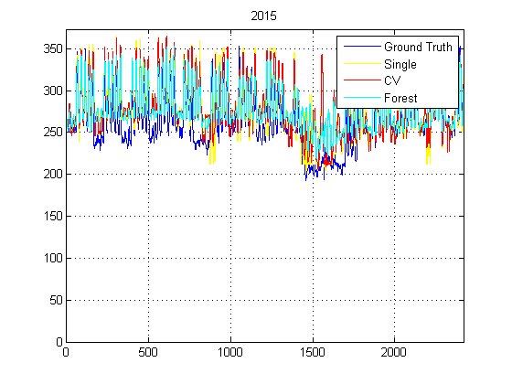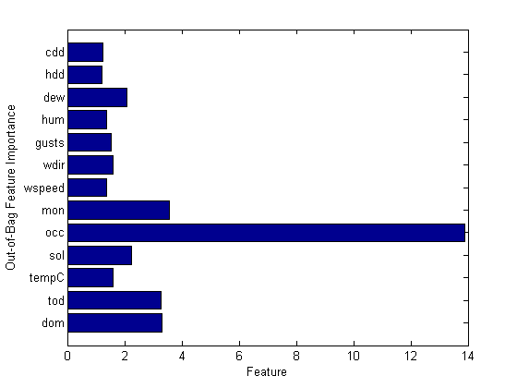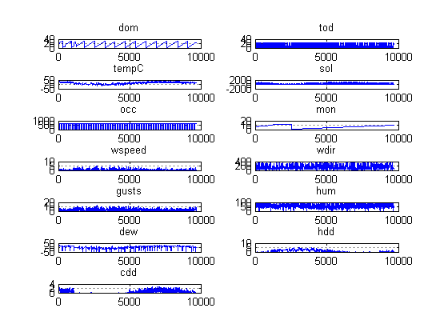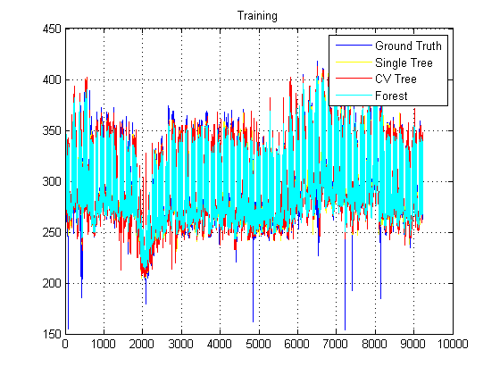

**DRL interpolated New Data**

Learning Regression Tree...

Elapsed time is 0.470401 seconds.

Training RMSE(W): 19.51, R2: 0.936, RMSE/peak: 0.0225, NRMSD: 3.49

Learning a cross validated tree...

Elapsed time is 3.842898 seconds.

Cross Validated Training RMSE(W): 28.77, R2: 0.861, RMSE/peak 0.0332, NRMSD: 5.14

Learning a Random Forest...

Elapsed time is 135.900852 seconds.

Random Forests Training RMSE(W): 20.71, R2: 0.928, RMSE/peak 0.0239, NRMSD: 3.70

Testing RMSE(W): 39.80, R2: 0.642, RMSE/peak: 0.0534, NRMSD: 7.16

Cross Validated Testing RMSE(W): 35.50, R2: 0.715, RMSE/peak 0.0476, NRMSD: 6.39

RF (Testing) RMSE(W): 32.59, R2: 0.760, RMSE/peak 0.0437, NRMSD: 5.87

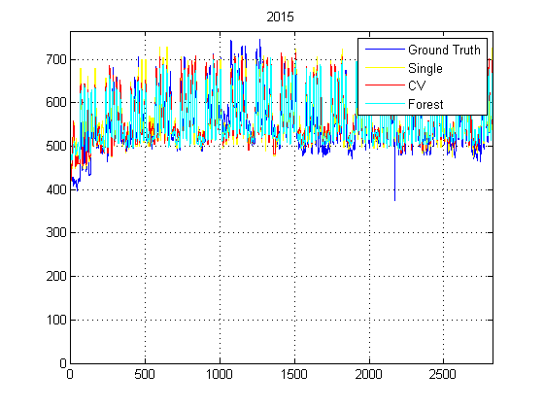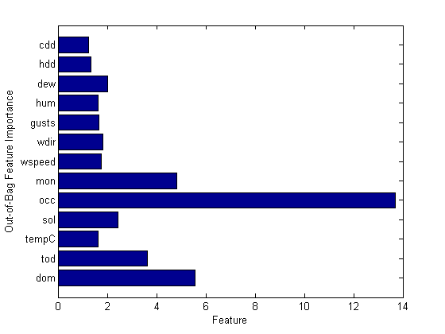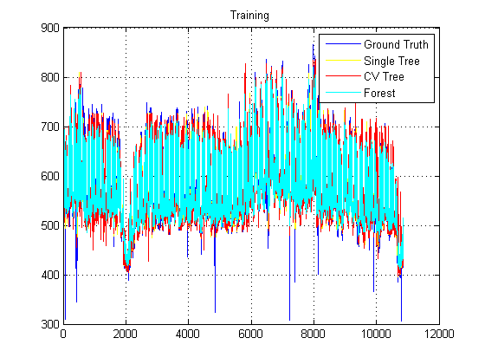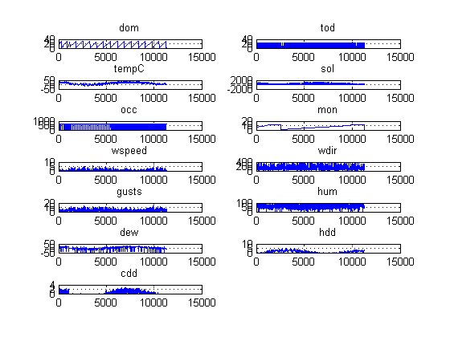

**DRL not interpolated New Data**

Learning Regression Tree...

Elapsed time is 0.714423 seconds.

Training RMSE(W): 13.74, R2: 0.969, RMSE/peak: 0.0159, NRMSD: 2.45

Learning a cross validated tree...

Elapsed time is 5.965955 seconds.

Cross Validated Training RMSE(W): 27.83, R2: 0.872, RMSE/peak 0.0321, NRMSD: 4.97

Learning a Random Forest...

Elapsed time is 195.191780 seconds.

Random Forests Training RMSE(W): 15.38, R2: 0.961, RMSE/peak 0.0178, NRMSD: 2.75

Testing RMSE(W): 37.95, R2: 0.647, RMSE/peak: 0.0509, NRMSD: 6.78

Cross Validated Testing RMSE(W): 32.27, R2: 0.745, RMSE/peak 0.0433, NRMSD: 5.77

RF (Testing) RMSE(W): 29.22, R2: 0.791, RMSE/peak 0.0392, NRMSD: 5.22

